POC 1 - Implementation

Mongo Collections

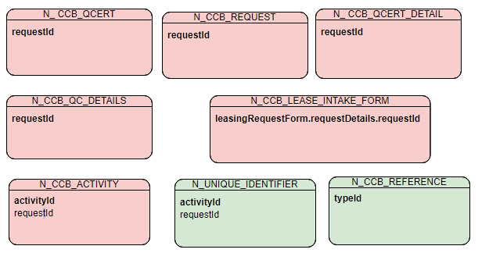

Collection Structure: N_CCB_REQUEST
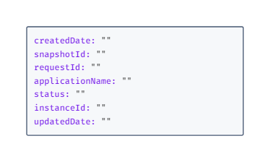

Collection Structure: N_CCB_ACTIVITY
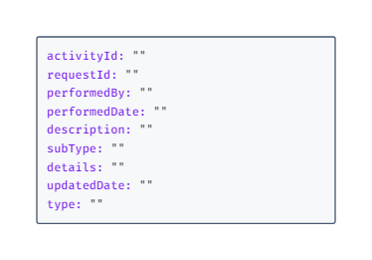

Collection Structure: N_CCB_LEASE_INTAKE_FORM
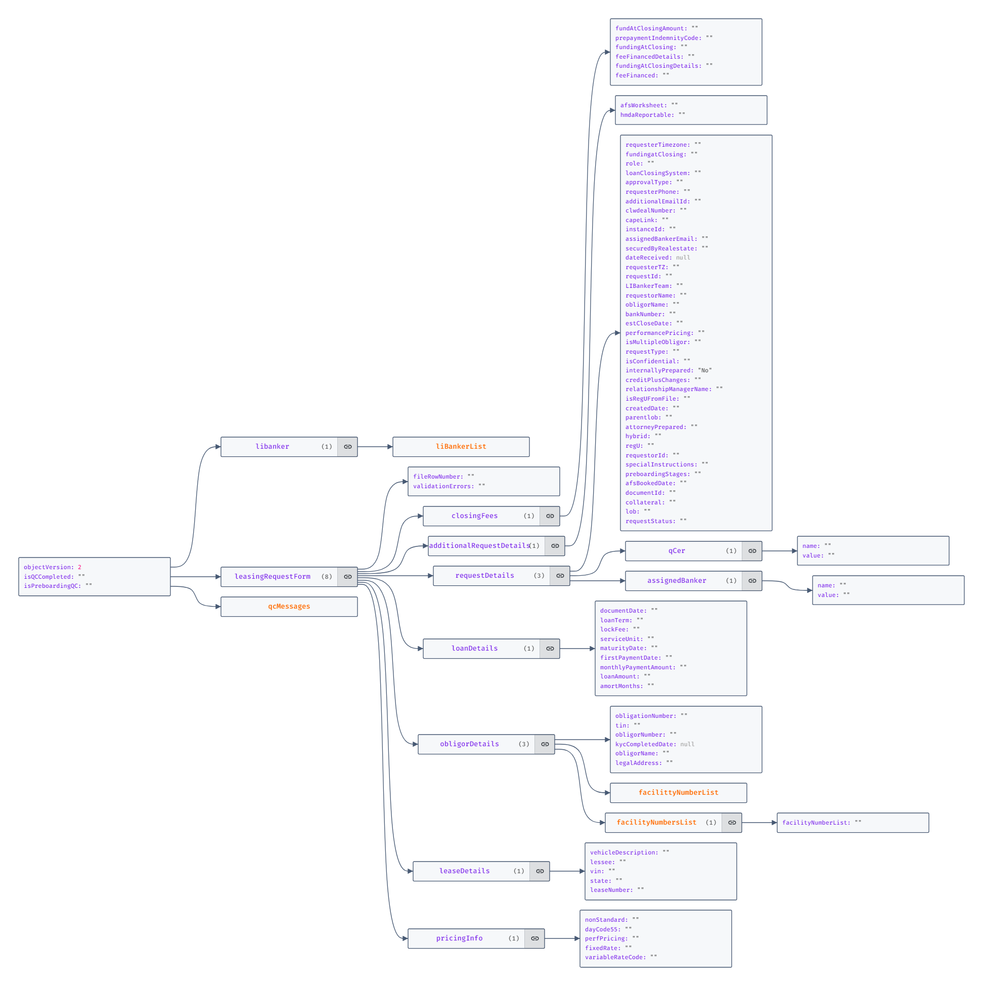

Collection Structure: N_CCB_QCERT
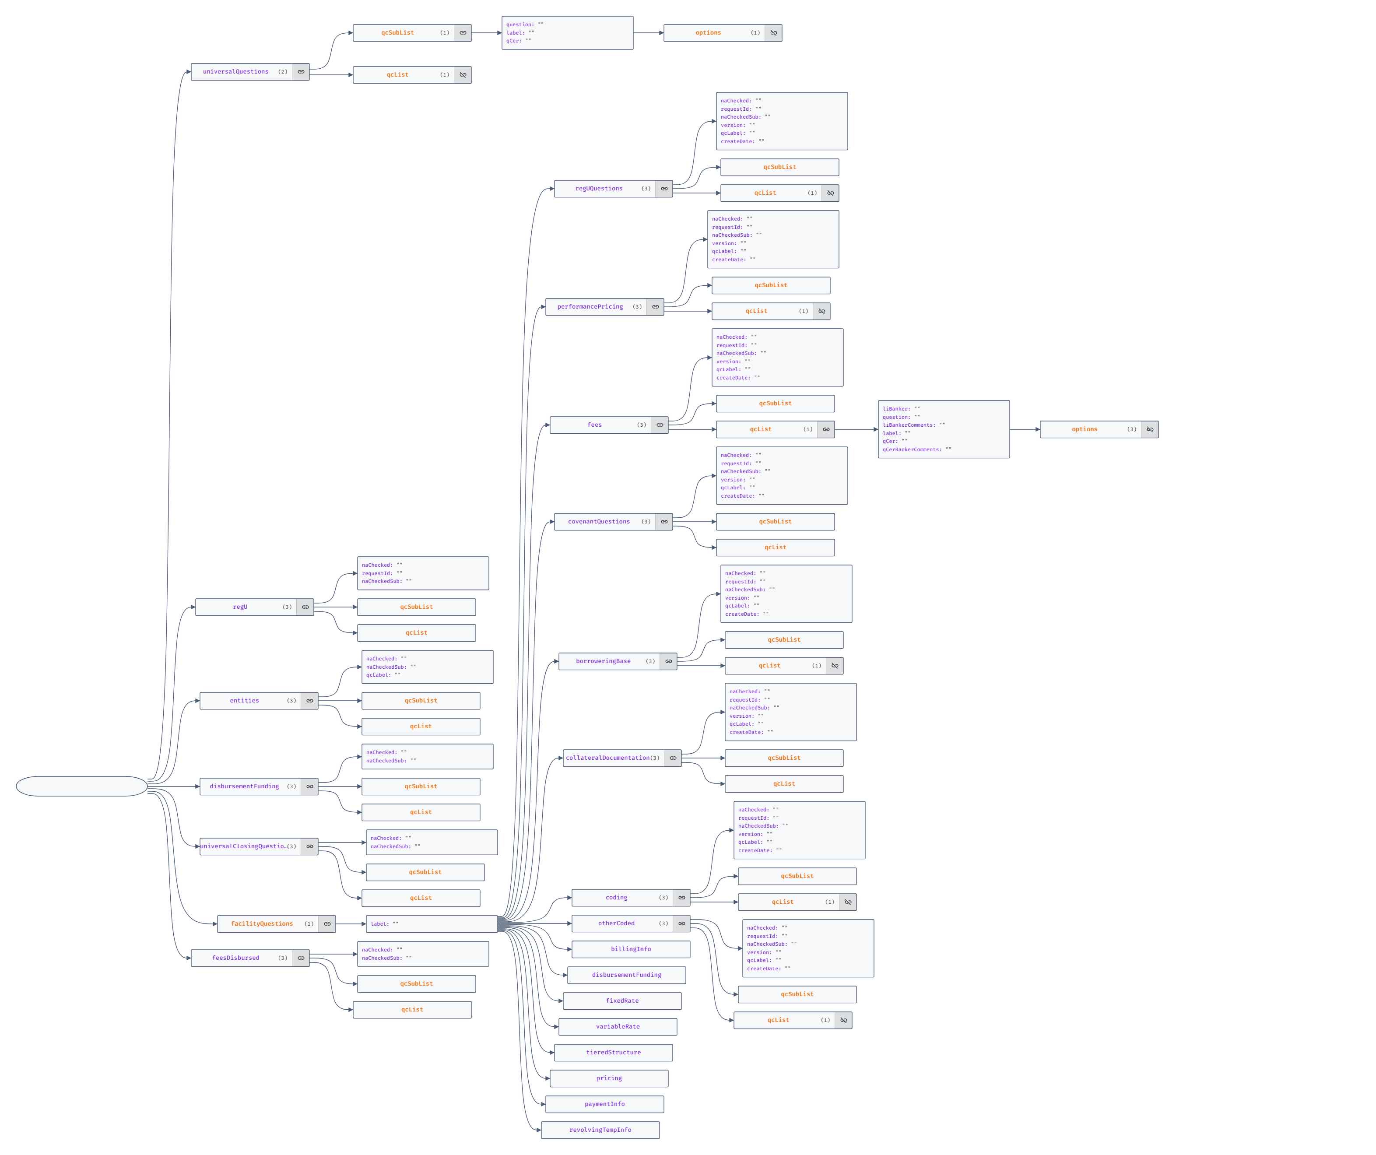

Collection Structure: N_CCB_QC_DETAILS
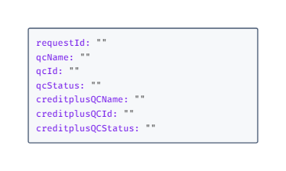

Collection Structure: N_ CCB_QCERT_DETAIL
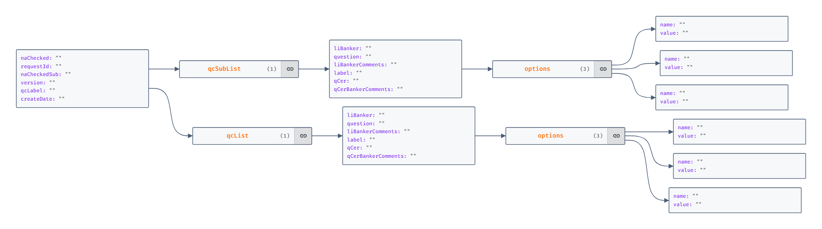

Collection Structure: N_CCB_REFERENCE
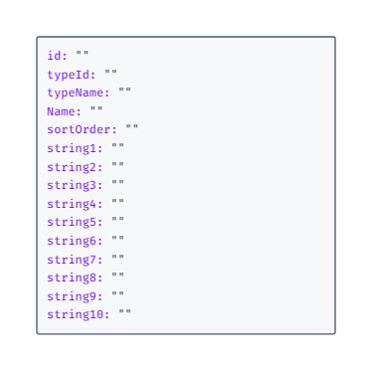

Collection Structure: N_ UNIQUE_IDENTIFIER
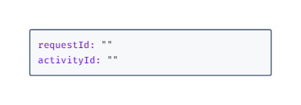

JSONS
Index for most of the Collection was based on requestId, the details are provided below.
Native Collection | Indexes
N_CCB_REQUEST | RequestId & Status
N_CCB_LEASE_INTAKE_FORM | leasingRequestForm.requestDetails.requestId
N_ CCB_QCERT | requestId
N_CCB_ACTIVITY | RequestId, Type  ActivityId
N_CCB_REFERENCE | typeId, String10
N_CCB_QC_DETAILS | RequestId
N_ CCB_QCERT_DETAIL | None
N_UNIQUE_IDENTIFIER | None

POC 2:
Collection Sample
{
"seqId": 1,
"EEID": "PERF0012",
"fullName": "Test Full Name 123",
"jobTitle": "jobTitle",
"department": "Dep1",
"businessUnit": "BU",
"gender": "M",
"age": 25,
"hireDate": "19/09/2021",
"annualSalary": 12121,
"bonus": 213,
"country": "USA",
"city": "New York",
"dob": "19/09/1999",
"clients": [
{
"cId": 12,
"refEId": 0,
"cName": "cname",
"domain": "domain",
"projects": [
{
"pId": 2500,
"refCId": 0,
"pName": "asdf",
"staffCount": 0,
"milestones": [
{
"mId": 125,
"refPId": 0,
"mName": "MilestoneName",
"targetDate": "2023-02-07"
}
]
}
]
}
]
}

Index
- GENDER
- CITY
- CLIENTS.DOMAIN
- CLIENTS.PROJECTS.STAFFCOUNT (desc order)
- CLIENTS.PROJECTS.LOCATION
- CLIENTS.PROJECTS.STARTDATE
- CLIENTS.PROJECTS.MILESTONES.MNAME
- CLIENTS.PROJECTS.MILESTONES.TARGETDATE

Hi Logan,

Hope you are doing fine.

Below are the information requested:

- Attached document has MongoDB collections and index definitions we created for POC application.
- Regarding Licensing Cost for our Current Production:
Here is the license cost:
SVCKSA69901A0FK is 24 cores, so the licenses were already purchased at about 84K and then yearly maintenance. THe other server has 8 cores so 28K for those already purchased license with yearly maintenance.
- Current Prod metrics extracted from SignalFx. Will send this Zip file tomorrow.

Please review and let us know if anything else needed.

Thanks,
Roshamithra(Rosha) Kamalasegaran
Assistant Vice President | Software Engineer Sr.
p. 612.973.8343 | c. 763.600.4057 | roshamithra.kamalasegaran@usbank.com

U.S. Bank
Meridian Crossing Build 2
2 Meridian Xing, Richfield, MN 55423-3963 | EP-MN-MN3T | usbank.com

From: Logan Frost <logan.frost@mongodb.com>
Sent: Wednesday, January 31, 2024 11:54 AM
To: Kamalasegaran, Roshamithra <roshamithra.kamalasegaran@usbank.com>
Cc: Sultan, Awais <Awais.Sultan@usbank.com>
Subject: [EXTERNAL] Re: MongoDB Sizing Follow Up

[WARNING] Use caution when opening attachments or links from unknown senders.

Thanks Rosha!
Were you able to pull a document and index definition from Compass, the MongoDB GUI? Copy and paste is fine!

On Wed, Jan 31, 2024 at 11:34 AM Kamalasegaran, Roshamithra <roshamithra.kamalasegaran@usbank.com> wrote:
Hi Logan,

We are trying to get the requested information. Submitted DBA consulting request to get our current licensing cost for PROD.

Will keep you posted.

Thanks,
Roshamithra(Rosha) Kamalasegaran
Assistant Vice President | Software Engineer Sr.
p. 612.973.8343 | c. 763.600.4057 | roshamithra.kamalasegaran@usbank.com

U.S. Bank
Meridian Crossing Build 2
2 Meridian Xing, Richfield, MN 55423-3963 | EP-MN-MN3T | usbank.com

From: Logan Frost <logan.frost@mongodb.com>
Sent: Friday, January 26, 2024 9:40 AM
To: Sultan, Awais <Awais.Sultan@usbank.com>; Kamalasegaran, Roshamithra <roshamithra.kamalasegaran@usbank.com>
Subject: [EXTERNAL] MongoDB Sizing Follow Up

[WARNING] Use caution when opening attachments or links from unknown senders.

Hi Awais and Rosha,

Thanks for your time yesterday. Here's a ballpark of what we are looking for to get more prescriptive on sizing.
- Sample document/data model from the PoC
- Sample Index
- Any available quantified metrics from Rajesh
At a very high level, here's what we might expect to save on infrastructure with a workload optimized for the document model.

Estimated licensing costs: $99,500 - 1 RAM pool, up to 256 GB

You can also build your own clusters in Atlas, on Azure and see how your different configurations would impact pricing. Once we have a real payload we would help architect and price this accordingly.

https://www.mongodb.com/pricing

RDBMS
Memory: 382.6 GB
CPU: 48vCPU, 24 physical
Storage: 3727.336 GB
Topology: 1 Primary, 1 Secondary
MongoDB
Memory: 191 GB
CPU: 24vCPU
Storage:1229.91 GB
Topology: 1 Primary, 2 Secondary

Atlas Tier: r80(128GB, 16vCPU) or m80(128GB, 32vCPU), 2048GB Disk
Notes: Typically see MongoDB deployments use about 50% of the resources of an RDBMS deployment for same application. Storage is typically compressed around 67%. CPU is not usually a performance bottleneck, though depends on the queries and their efficiency. CPU is usually most impacted by aggregations($lookup and $sort) and unoptimized queries, such as those doing an in-memory sort with no supporting index.

--

{ name : "Logan Frost",
title : "Enterprise Account Executive",
phone : "651-503-1402",
location : "Minneapolis, MN",
linkedin : "linkedin.com/in/loganrfrost/" }
U.S. BANCORP made the following annotations
---------------------------------------------------------------------
Electronic Privacy Notice. This e-mail, and any attachments, contains information that is, or may be, covered by electronic communications privacy laws, and is also confidential and proprietary in nature. If you are not the intended recipient, please be advised that you are legally prohibited from retaining, using, copying, distributing, or otherwise disclosing this information in any manner. Instead, please reply to the sender that you have received this communication in error, and then immediately delete it. Thank you in advance for your cooperation.
---------------------------------------------------------------------

--

{ name : "Logan Frost",
title : "Enterprise Account Executive",
phone : "651-503-1402",
location : "Minneapolis, MN",
linkedin : "linkedin.com/in/loganrfrost/" }

